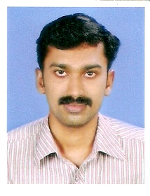 Name: RETHEESH R
E-mail: retheesh500@gmail.com
Phone: 09747151503
Objectives :
To serve in a challenging job in an organization with leading edge technologies, where I can utilize my knowledge and can have a continual advancement of skill.
Experience (4.3 years)
-Dhanlaxmi Bank Ltd - Sales Officer (07/06/2011 to Till date)
Handling Responsibility for achieving the branch sales target in Business Banking, ensuring high quality service & customer relationship management. Ensuring cost & productivity norms are met & compliance with banking rules, regulations & procedures.
-Goal is to Grow accounts profitability by maintaining a high service standard and compliance.
-Generate the cross selling business from existing customers by selling other products.
-Maintain and develop customer relationships, new business, and periodic visit to existing customers.
-Manage and track the leads and maintain DSR on regular basis.
IT SKILLS
Well versed with MS office, Internet Applications & Core Banking Software like Oracle Flexcube
Qualifications :
MSc Physics with 72% marks
BSc Physics with 67% marks
Plus Two with 79% marks
SSLC with 69% marks
Personal Profile
DOB :09-05-1988, Age: 27, Sex : Male
Maritial Status: Single
Father’s Name: Reghunadh P A
Mailing Address:
Thulasi house
Puzhavathu
Changanacherry
Kottayam
kerala
Pin-686101

I hereby declare that the information which i mentioned above is true to my best of my knowledge and belief.
Retheesh R

